Kol Simcha Torah Gazette
For parshas vayechi 5786
Vol 10 Issue 13 (Whole #479) 14 Teveth 5786/ January 3, 2025
Printed L’illuy nishmas Nechama bas R’ Noach, a”h
For a free subscription, please forward your request to keren18@juno.com
Past emails can be found on the website ShabbosStories.com under Brooklyn Torah Gazette

After Fire Destroys Boro Park Matzah Bakery, Owner Hangs Giant Sign Declaring
“Ein Od Milvado”



A well-known matzah bakery in Boro Park was completely destroyed in a major fire last week, drawing an extraordinary response from its owner that has since resonated across the neighborhood and beyond.
The blaze tore through the famous Boro Park Matzah Bakery on 14th Avenue, reducing the facility to ashes.
Firefighters battled the flames for nearly seven hours before finally bringing the inferno under control, according to local reports.
As firefighters worked to extinguish the fire, the bakery’s owner, R’ Chaim Brown, a chossid of Vizhnitz, stood nearby watching his livelihood go up in flames. Rather than reacting with anger or despair, he distributed sheets of paper to onlookers bearing the words “Ein Od Milvado,” and repeatedly called out the phrase, expressing his firm belief that everything comes from Hashem and is ultimately for the good, even amid enormous financial loss at the peak of the matzah-baking season.

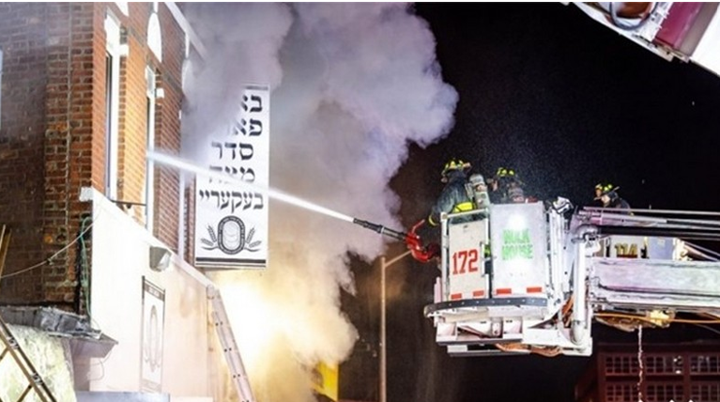

In footage recorded at the scene, R’ Chaim can be heard explaining his outlook with striking clarity. When one bystander asked whether a malfunctioning oven may have sparked the fire, he replied that it was Hashem Above who caused it. “When Hashem gives a person a slap,” he said, “you don’t ask questions.”
True to his word, R’ Chaim later took his message a step further. A massive banner bearing the words “Ein Od Milvado” was hung prominently on the remains of the bakery, serving as a public declaration of faith and acceptance. The sign, now impossible to miss along the busy avenue, has become a powerful symbol of emunah.

Reprinted from the December 23, 2025 posting on Matzav.com
The Sage Rabbi Yitzchak
And the Unity of the
Mundane and the Spiritual
From the Teachings of the Lubavitcher Rebbe
Rabbi Menachem Mendel Schneerson, Zt”l
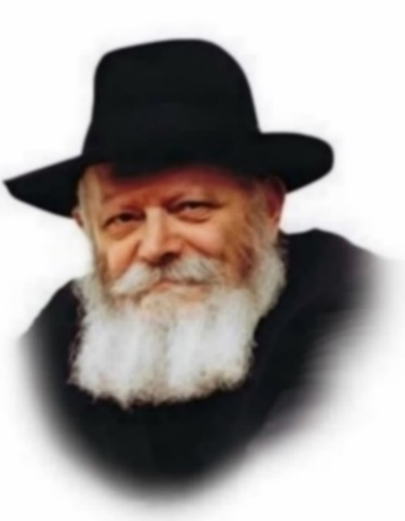
With this week's Torah portion, Vayechi, we conclude the Book of Genesis. "So Joseph died, being one hundred and ten years old...and he was put into a coffin in Egypt" is its final verse.
This conclusion to the entire Book is somewhat surprising, in light of the principle that "one should always end on a positive note." Why couldn't Genesis have concluded a few verses back, when we learn that Joseph lived a long life and merited to see grandchildren and great-grandchildren?

Why couldn't the description of Joseph's death have waited until the Book of Exodus?
We must therefore conclude that Joseph's passing is somehow related to the theme of Genesis itself.
The primary difference between Genesis and the other four Books of Moses is that Genesis relates the early history of our Forefathers and the twelve tribes - the preparation for our existence as a distinct nation - whereas the other four books contain a narrative of our history as a people.
The Book of Genesis begins with an account of the creation of the world.
The Sage, Rabbi Yitzchak, explained that although the Torah should have begun with a practical commandment, G-d chose to commence with the Creation to refute the arguments of the Gentiles, who would one day claim that the Jews had stolen the land of Israel from the nations who lived there prior to its conquest.

To counter their assertion, the Jews will say, "The entire world belongs to G-d; He created it and divided it as He saw fit. It was His will to give it to them, and it was His will to take it from them and give it to us."

Surely G-d did not change the entire order of His Torah just to supply an answer to the arguments of the Gentiles. The comments of Rabbi Yitzchak must therefore contain a more fundamental teaching for the Jewish people as a whole.
The nations of the world are cognizant of the Jew's special mission. Their claim, however, is that precisely because Jews are different, they should limit themselves to the spiritual service of G-d and not tie themselves down to a physical land.

Because Jews are a nation like no other, they have no right to claim ownership of a homeland. To the non-Jew, the spiritual and physical realms are incongruous and incompatible.

"The entire world belongs to G-d," the Jew explains - the mundane as well as the spiritual. Both require sanctification through the light of holiness - the sacred mission of the Jew.

With this concept the Book of Genesis begins, and on this note it concludes. Joseph's coffin remained in Egypt to strengthen and inspire the Children of Israel during their exile there. Joseph is symbolic of the ability of the Jewish people to overcome even the most difficult of obstacles, imbuing even the lowliest physical matter with holiness and bringing the long-awaited Redemption.
Adapted from Likutei Sichot of the Rebbe, Vol. 30

Reprinted from the Parashat Vayechi - December 20, 2002 - 15 Tevet, 5763 edition of L’Chaim, a publication of the Lubavitch Youth Organization. Adapted from Likutei Sichotth of the Lubavitcher Rebbe.

Rav Avigdor Miller on
Slavery in Goshen

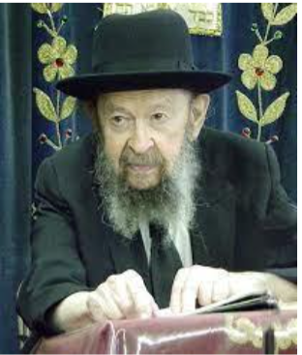

QUESTION: According to what the Rav just said, if the Bnei Yisroel had listened to the advice of Yosef and kept separate from the Egyptians they would have stayed all together in the land of Goshen and all of these problems that came up would not have happened. But didn’t Hashem already promise Avraham Avinu that his descendants would work with avodah kasheh b’eretz lo lohem, with difficult labor in a foreign land?

ANSWER: My friend, I see that you have not been reading Behold A People (the first volume of the Rav’s 3 Volume Jewish History series)! Alright, there are worse things than that.

Being in the land of Goshen was called avodah kasheh. It was a difficult servitude. Why? Because even Yosef, who certainly was not a menial slave, even Yosef was unable to leave Mitzrayim. Even for his father’s funeral he wasn’t given permission to leave unless he left over everything that he possessed in the land of Mitzrayim. In addition, he had to explain to Pharaoh that his father made him swear. If not for that, he wouldn’t have been let out.
And so, we see that Yosef and his people was enslaved – they weren’t free to leave. And to be forced to remain in a foreign country against your will, that’s included in the calculation of avodah – that’s labor. Who said that slavery has to mean bricks? Bricks is only a result of mingling with gentiles. When you start mingling with them, so you get bricks.

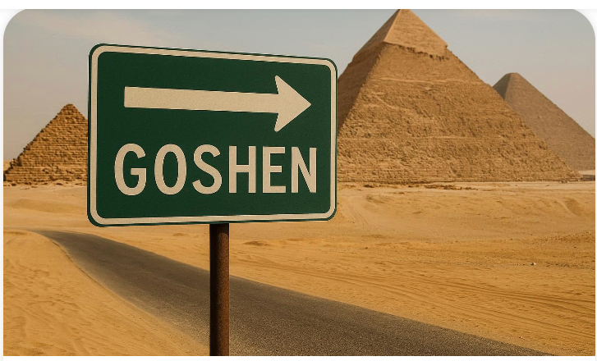

Like it states in Tehillim (106:35) about the Jews in Mitzrayim: וַיִּתְעָרְבוּ בַגּוֹיִם – And they mingled among gentiles, וַיִּלְמְדוּ מַעֲשֵׂיהֶם – and they learned their deeds. Oh! When they began to learn the ways of the Egyptians, then it says, הָפַךְ לִבָּם לִשְׂנֹא עַמּוֹ – that’s when Hakodosh Boruch Hu turned the hearts of the Egyptians to hate His people, לְהִתְנַכֵּל בַּעֲבָדָיו – to scheme and to plot against His servants. It says that openly in Tehillim.

So, Dovid Hamelech is explaining that the bricks came because they began to mix. Had they not mixed, they would have been in an honorable servitude; it would have been an avodah kasheh but without bricks. (Adapted from a classic Thursday night hashkafah lecture by Rav Miller in July 1973.)

Reprinted from a recent Toras Avigdor email.

Thoughts that Count
for Our Parsha

Gather yourselves together that I may tell you what will befall you in the end of days (Gen. 49:1)
Rashi explains that Jacob wished to tell his children when Moshiach would come. However, "the Divine Presence departed" and he was thus unable to do so. But why was it necessary for the Divine Presence to depart? Why didn't G-d simply forbid Jacob from revealing this information? What happened, however, was that Jacob foresaw all the suffering his children would be forced to endure throughout the exile, and became sad. As "the Divine Presence only rests on a joyful person," it departed as a result of his mood. (Rabbi Chanoch Tzvi of Bendin)

Let them grow into a multitude (yidgu) in the midst of the earth (Gen. 48:16)
This blessing alludes to the fact that the existence of the Jewish people is not dependent on the forces of nature, but is supernatural. The word "yidgu" is derived from the Hebrew word for fish - "dag," the intent being that there should be as many Jews as there are fish. Fish, however, cannot live "in the midst of the earth"; Jacob's blessing therefore intimates that his children will survive even under conditions that would annihilate another nation. (Chatam Sofer)

And Joseph went up to bury his father (Gen. 50:7)
A person is judged with the same yardstick he uses to judge others. Joseph, the most respected of the brothers, involved himself personally in the burial of his father. He thereby merited that none other than Moses himself would later carry his bones back to the land of Israel. (Sotah, 9:4)

Reprinted from the Parashat Vayechi - December 20, 2002 - 15 Tevet, 5763 edition of L’Chaim, a publication of the Lubavitch Youth Organization.

Table Manners
By Rabbi Paysach Krohn



R’ Dovid Leibowitz once described a Friday night scene: A family returns from shul and gathers around a beautifully set Shabbos table. As the father takes his seat, he notices the challos are missing from under the challah cover. Irritated, he snaps, “Who forgot the challos?”
His wife reddens in embarrassment, the children look down in shame, and guests shift uncomfortably. What the father misses is the lesson lying right before him. The challah is covered, explains the Mishnah Berurah, to spare it embarrassment when Kiddush takes precedence. Challah has no feelings — yet we must treat it with symbolic sensitivity.
How much more must we be careful not to hurt the feelings of the people around our table! In shaming his family over a minor mistake, the father ignores the very message the challah cover is meant to teach. The yahrzeit of R’ Dovid Leibowitz zt”l is 15 Kislev. May his merit protect us. (The Maggid Speaks)

Reprinted from the Parshas Vayishlach 5786 email of The Weekly Vort.
Avraham Fried Shares Unforgettable Moment: “The Police Officer
Opened My Wallet”

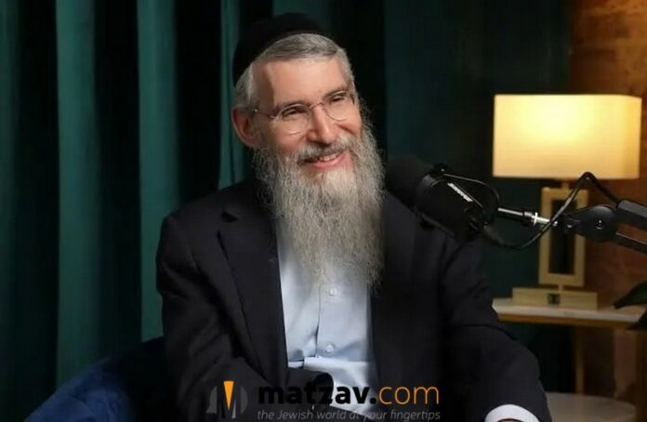

Moments before stepping onstage this week, famed singer Avraham Fried recounted a deeply personal incident that occurred during a recent concert tour in Europe, a moment he said he will never forget. At a train station abroad, a police officer suddenly approached him with his lost wallet in hand, leading to an emotional exchange that left a strong impression on the singer.
Speaking with Dudi Kepler, Fried described the whirlwind of travel that preceded the story. “I was in France,” he said, explaining that he had been rushing from place to place: “I was running from one place to another for concerts — Belgium, France, London, Zurich.”
He recalled standing at a train gate in one of those countries, waiting for the train to arrive. “Suddenly I see a tall police officer standing in front of me. He walks over and asks me, ‘Is this yours?’ I look at his hand and see my wallet. ‘Yes,’ I told him immediately. ‘It’s mine.’”
Fried said he was completely confused as to how the wallet had ended up with the officer. “I didn’t understand. I asked the officer: Ribono Shel Olam, this is mine — where did you find it?” The officer explained that Fried had forgotten it on the counter when purchasing his ticket.
But the singer still wondered how the officer had known to whom it belonged in such a crowded station. “I still didn’t understand. I said to the officer: Wait, there are thousands of people here — how did you know this wallet is mine?”
The officer responded that he had no choice but to open it. “He said: ‘With respect, rabbi, I had no choice. I opened the wallet, and inside was a picture of your father.’
“It was a picture of the [Lubavitcher] Rebbe.”
Fried concluded the story with emotion: “So on the train, on the way to the next place, I kept thinking that even a police officer, not Jewish, knows and feels that the [my] Rebbe is a father.”

Reprinted from the December 12, 2025 posting on Matzav.com

82 Years After Being Killed in China, Jewish World War II Pilot Brought Home for Burial

More than eighty years after he was killed in combat, a Jewish American pilot who fought in World War II has finally been laid to rest, following the identification of his remains and a burial ceremony in South Carolina, according to the US Department of War, the Times of Israel reports.
The aviator, Lt. Morton Sher, was 22 years old when he died on Aug. 20, 1943, during an Allied air operation over China. Flying a P-40 Warhawk fighter-bomber as part of the China-Burma theater, Sher’s aircraft went down in Hunan province after a mission against Japanese forces. His plane crashed into a rice paddy in Xin Bai Village and burned, leading officials at the time to believe that no remains could be recovered.
In the aftermath of the crash, Sher’s squadron erected a memorial stone near the site, and a postwar Army review conducted in 1947 formally classified him as unrecoverable. That same year, his mother, Celia Sher, was presented with his Purple Heart, and for decades the family’s connection to him consisted only of letters, photographs, and memories preserved from the war years.

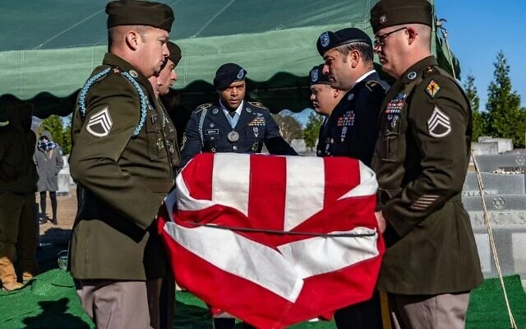

Sher had been born on December 14, 1920, in Baltimore, Maryland. His family later relocated to Greenville, South Carolina, where they were active members of Congregation Beth Israel. As a teenager, he helped found a local chapter of the B’nai B’rith Youth Organization’s Aleph Zadik Aleph fraternity. He later attended the University of Alabama, joining the Kappa Nu fraternity, managing the school’s basketball team, and participating in ROTC before entering the Air Force to pursue aviation.
Assigned to the 76th Fighter Squadron of the 23rd Fighter Group in the 14th Air Force, Sher flew escort and combat missions over China. An Air Force historian cited by the Department of War noted that he had already achieved three aerial victories by the time of his death. In 1942, after his aircraft was hit by seven Japanese fighters following a successful raid on Hong Kong, Sher sustained a minor head injury but chose to return to combat rather than seek reassignment.
Letters sent home and interviews published during the war reflected Sher’s strong attachment to his mission and to the people he was helping defend. The Department of War reported that after making an emergency landing in a Chinese village in October 1942 due to engine trouble, Sher was welcomed by residents with food and celebrations. He later described singing American songs for villagers and being escorted back to base through mountain towns.
A renewed effort to locate his remains began in 2012, when a private citizen contacted the Defense POW/MIA Accounting Agency after discovering a photograph of the memorial stone placed by Chinese villagers at the crash site. Initial searches did not yield results, but a more extensive recovery mission in 2024 uncovered aircraft debris and human remains in Xin Bai Village near Hengyang. Subsequent DNA analysis confirmed that the remains belonged to Sher.
Sher was finally buried on December 14 — his birthday — in Greenville, where a headstone bearing his name and a Star of David had stood in anticipation for decades. During the burial, relatives and friends placed soil from Israel onto his grave.
At the memorial service, Sher’s nephew, Bruce Fine, reflected on his uncle’s life and choices. “He filled his pages of life with meaning,” Fine said, according to the Department of War.
Fine also recounted a letter Sher had written the day before he was killed, explaining that he had declined a safer assignment as an instructor because he found combat “too exciting” to leave.
“Our family tree produced a real hero,” Fine said. “The kind you read about and see on the big screen, except he was real. We hope his bravery and his courage will inspire the family members who follow us to believe that anything you can dream can be truly possible if you’re willing to commit to it and work hard to achieve it.”

Reprinted from the website of Matzav.com

Ben Shapiro’s Moral Courage
By Rabbi Steven Burg

In standing up to Nick Fuentes, Tucker Carlson, and Candace Owens, Ben Shapiro deserves support for calling out right-wing antisemitism and speaking the truth, even when it’s costly.
This past weekend at Turning Point USA, Ben Shapiro took the stage and did what too few have been willing to do: he told the truth and drew a line in the sand against antisemitism in the conservative movement.
Shapiro didn’t mince words. He called out Nick Fuentes as exactly what he is, a pro-Hitler racist whose venom extends far beyond Jews to include women – including the vice president’s wife – Black Americans, Asian Americans, and countless others.

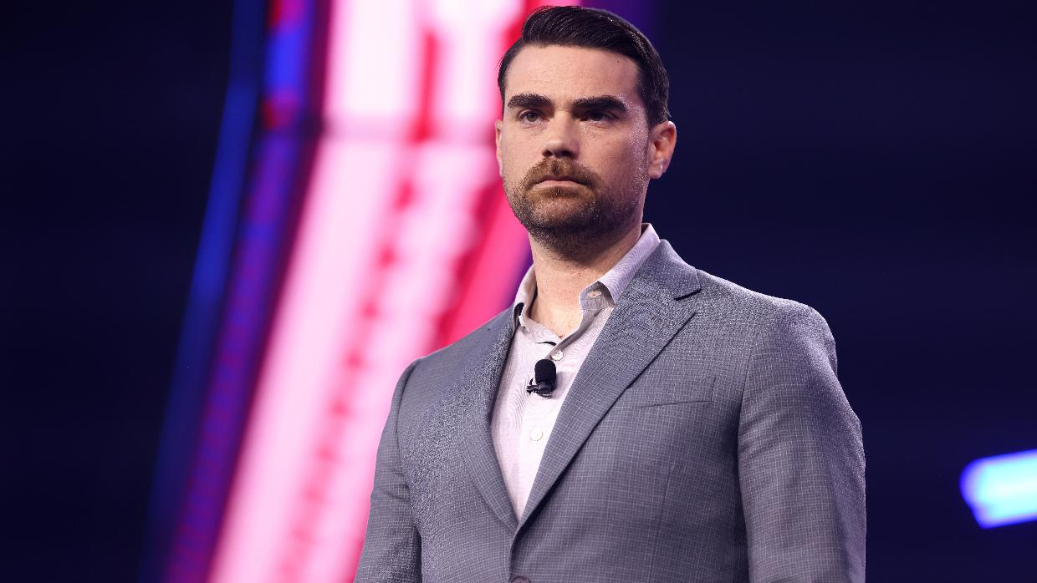
Ben Shapiro

He confronted the troubling reality that figures like Tucker Carlson have given Fuentes a platform, attempting to mainstream his toxic ideology. He challenged Carlson’s increasingly anti-Israel rhetoric and Candace Owens’ transformation from someone who built her career with support from Israeli venture capitalists to a voice that demonizes the Jewish people.

Fighting Jew Hatred at Turning Point USA
Turning Point USA draws thousands of young, impressionable conservatives. Recent studies, including work highlighted by Yair Rosenberg in The Atlantic, show that antisemitism among young people is rising at an alarming rate. Despite attempts by some politicians to blame immigration, the data tells a different story. This hatred is homegrown and spreading.
We cannot allow ourselves to be used as political pawns. Too many politicians now cynically position themselves as anti-Israel and anti-Jewish because they believe it will win them votes. They see a path to power and take it, regardless of the damage they inflict.
The past three and a half years have taught us a crucial lesson: you cannot separate the Jews from Israel. The BDS movement understood this from the beginning. Overt antisemitism faced resistance, so activists cloaked their hatred in anti-Zionism instead. It’s the same poison in a different bottle.

Reveals a Stunning Moral Blindness
What’s particularly disturbing is the response from some quarters. Megyn Kelly’s defense of people like Owens and Carlson – “but they’re my friends” – reveals a stunning moral blindness. Friendship cannot excuse hateful content. Personal relationships cannot override our responsibility to stand against bigotry in all its forms.
Shapiro joined a small but vital group of truth-tellers who have refused to stay silent, warning both the Left and Right that they’re heading down dangerous paths. History has shown us repeatedly that what begins with the Jews never ends with the Jews.
The Left has embraced a particularly visible and aggressive form of antisemitism, evident across college campuses and progressive movements and in certain segments of the Democratic Party. But what Shapiro confronted this weekend was an attempt to align an entire conservative movement with anti-Israel sentiment and antisemitic tropes. If we don’t stop this now, it will only grow.

That’s What Moral Courage Looks Like
And he took real risks by speaking out, saying things that could affect his livelihood and standing. He did it because he believed the people on the other side were fundamentally wrong. That’s what moral courage looks like.
In that room full of young conservatives, Shapiro delivered a message they needed to hear: know your values and stand by them. If you want to traffic in hate, own it, but don’t wrap it in conservatism. Don’t pretend it’s something noble or principled.
People like Ben Shapiro, who stand in the trenches fighting this battle, deserve our support. They are defending all of us, not just the Jewish community, because when hatred is normalized, when bigotry finds mainstream acceptance, everyone ultimately suffers.
The battle at Turning Point USA this weekend was a microcosm of a larger struggle. Will we allow antisemitism to infect our political movements from all sides? Or will we demand better from our leaders, our media figures, and ourselves?
Rejecting hatred in all its forms, even when it comes dressed in political expediency, is not just good for the Jews – it’s good for America.

Reprinted from the current website of aish.com. This op-ed originally appeared in the Jerusalem Post.

